Indija izboljšala položaj za 23 mest in je 77. na lestvici Svetovne banke o pogojih poslovanja
India improves rank by 23 positions to rank at 77 in World Bank’s Doing Business Report

- The World Bank released its latest Doing Business Report (DBR, 2019) on 31st October 2018. India has recorded a jump of 23 positions against its rank of 100 in 2017 to be placed now at 77th rank among 190 countries assessed by the World Bank. India's leap of 23 ranks in the Ease of Doing Business ranking is significant considering that last year India had improved its rank by 30 places, a rare feat for any large country of the size of India. As a result of continued efforts by the Government, India has improved its rank by 53 positions in last two years and 65 positions in last four years [2014-18].

- The Doing Business assessment provides objective measures of business regulations and their enforcement across 190 economies on ten parameters affecting a business through its life cycle. The DBR ranks countries on the basis of Distance to Frontier (DTF), a score that shows the gap of an economy to the global best practice. This year, India’s DTF score improved to 67.23 from 60.76 in the previous year.

- India has improved its rank in 6 out of 10 indicators and has moved closer to international best practices (Distance to Frontier score) on 7 out of the 10 indicators. But, the most dramatic improvements have been registered in the indicators related to 'Construction Permits' and 'Trading across Borders'. In grant of construction permits, India's rank improved from 181 in 2017 to 52 in 2018, an improvement of 129 ranks in a single year. In 'Trading across Boredrs', India's rank improved by 66 positions moving from 146 in 2017 to 80 in 2018. The changes in six indicators where India improved its rank are as follows:

S. No. | Indicator | 2017 | 2018 | Change
1 | Construction Permits | 181 | 52 | +129
2 | Trading Across Borders | 146 | 80 | +66
3 | Starting a Business | 156 | 137 | +19
4 | Getting Credit | 29 | 22 | +7
5 | Getting Electricity | 29 | 24 | +5
6 | Enforcing Contracts | 164 | 163 | +1
Overall rank |  | 100 | 77 | +23

- The important features of India's performance this year are:
- The World Bank has recognized India as one of the top improvers for the year.
- This is the second consecutive year for which India has been recognized as one of the top improvers.
- India is the first BRICS and South Asian country to be recognized as top improvers in consecutive years.
- India has recorded the highest improvement in two years by any large country since 2011 in the Doing business assessment by improving its rank by 53 positions.
- As a result of continued performance, India is now placed at first position among South Asian countries as against 6th in 2014.
- Further, India has improved its rank among BRICS countries from 5th in 2014 to 3rd in 2018.

5. Indicatorwise highlights of India’s performance are:

- Dealing with Construction Permits –
- Procedures reduced from 37 to 20 in Mumbai and from 24 to 16 in Delhi
- Time reduced from 128.5 to 99 days in Mumbai and from 157.5 to 91 days in Delhi
- Building quality control index improved from 12 to 14 in Mumbai and 11 to 14 in Delhi
- Cost of obtaining construction permits reduced from 23.2 percent to 5.4 percent
- DTF score improved from 38.80 to 73.81

- Trading Across Borders –
- Changes in time and cost are as follows:
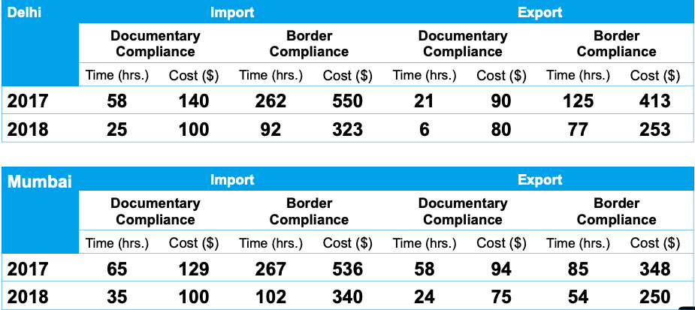

- Robust Risk Management System has reduced inspections significantly
- e-Sanchit allows traders to file all documents electronically
- Time and cost to export reduced through the introduction of electronic self-sealing of container at the factory

- Starting a Business -
      - Procedures reduced from 11 to 10 in Delhi and 12 to 10 in Mumbai
      - Time reduced from 30 to 16 days in Delhi and 29.5 to 17 days in Mumbai
      - PAN, TAN, DIN now merged with SPICe making it a single form for company incorporation
      - No requirement of inspection for registration under Shops & Establishment in Mumbai
      - Distance to Frontier improved from 75.40 to 80.96

- Getting Credit
- Rank improved from 29 to 22
- DTF improved from 75 to 80
- Strength of legal rights index improved from 8 to 9
- Secured creditors will now be repaid first during business liquidation hence given priority over other claims

- Getting Electricity
- Procedures reduced from 5 to 3 in Delhi and 5 to 4 in Mumbai
- DTF improved from 85.21 to 89.15

- This significant improvement is credited to a strong commitment of the Government to carry out comprehensive and complex reforms, supported by a bureaucracy which has changed its mindset from a regulator to a facilitator. The Government has undertaken an extensive exercise of stakeholder consultations to understand challenges of the industry, government process re-engineering to provide simplified and streamlined processes to create a more conducive business environment in the country. As a result of continued efforts, India's rank has improved as follows:

Year | 2014 | 2016 | 2017 | 2018
Overall rank | 142 | 130 | 100 | 77
DTF | 53.97 | 56.05 | 60.76 | 67.23

The eight indicators in which India has improved its rank over last four years are as follows:

S. No. | Indicator | 2014 | 2018 | Change
1 | Construction Permits | 184 | 52 | +132
2 | Getting Electricity | 137 | 24 | +113
3 | Trading across Borders | 126 | 80 | +46
4 | Paying Taxes | 156 | 121 | +35
5 | Resolving Insolvency | 137 | 108 | +29
6 | Enforcing Contracts | 186 | 163 | +23
7 | Starting a Business | 158 | 137 | +21
8 | Getting Credit | 36 | 22 | +14

- Various Departments and Ministries worked tirelessly to implement reforms. Implementation of reforms required close coordination within various Ministries and government agencies. It involved:
  - DIPP prepared reform action plan based on global best practices, with support of World Bank’s expert team
  - Identification of nodal Departments and constitution of Task Force for each indicator. DIPP sensitizing Departments and worked with them for reform implementation
  - Development of a Communication Plan for Dissemination of reforms to users and other stakeholders, to generate awareness and receive feedback.
    - DIPP engaged expert agencies to receive regular industry feedback on reforms
    - Consulted stakeholders frequently to understand the gaps in reform implementation
    - Created WhatsApp groups to share reforms and address concerns of users
    - Conducted focused group discussions and one-to-one meetings with users
    - Ran twitter Polls and conducted live Twitter chat sessions to gauge user perception
  - Identified corrective measures based on feedback received
  - Regular review of reforms and removing bottlenecks in implementation
  - Indian delegation visited World Bank multiple times to explain the reforms implemented and understand areas of improvement
*****

